Task scheduling system
Kamchatnyi Vladyslav, Zhurakovska Oksana
Department of Information Systems and Technologies
Igor Sikorsky Kyiv Polytechnic Institute
Kyiv, Ukraine
kamchatnyi.vladyslav@lll.kpi.ua, o.zhurakovska@kpi.ua

Abstract. The scheduling system allows a potential user to determine the date and time interval of a new task using heuristic algorithm that considers already existing tasks. The system consists of a client and a server side. The former one is a mobile application for managing user’s daily tasks with the possibility to build a new schedule with heuristic algorithm. The latter is a storage of user’s account data and added tasks.

Key words: schedule, information system, scheduling algorithm, decision-making support.

Introduction
Nowadays, the combination and balance of work and free time is an important part of every person’s daily life. The variety of tasks and their number is growing, but the amount of time available remains constant. It is important to be able to properly allocate this time due to its limited nature and try to increase the efficiency of tasks simultaneously. Another important issue is reducing the burden of regular workflow, which can be achieved with balanced distribution of tasks.
This problem can be solved with a system that recommends a task schedule based on the user’s workload, existing and new tasks durations, complexities and priorities.

System structure
The system consists of several components that make up its client-server architecture [1]. Fig. 1 presents the schematic structure of the system, highlighting three key components: the client, the server and the database.
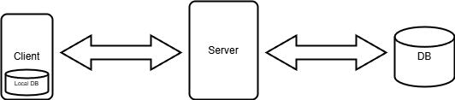
- System architecture diagram

The client-side component of the system is a mobile application developed for the Android operating system. It enables users to perform CRUD operations [2] on their tasks and request a schedule from the system when needed. Furthermore, the client includes a local database that stores user-created tasks.
The server-side component of the system is responsible for processing HTTP requests [3] to authorize users in the application using JWT [4] and for propagating changes in user task data to the database.
The database stores user account information, JWTs, received in requests from the server and tasks created by users.

Scheduling algorithm
Input data:
D = { D₁, D₂, ..., D_{k}, ..., D_{m} } – set of dates defined by range [current date, approximate deadline specified by the user];
J = { J₁, J₂, ..., J_{i}, ..., J_{n} } – set of tasks, each characterized by the following parameters:
p_{i} – task duration;
pr_{i} – task priority, equals to 1 if task has low priority; equals to 2 if task has high priority;
d_{i} – task difficulty, equals to 1 if task is normal; equals to 2 if task is difficult;
f_{i} – task difficulty, equals to 0 if task is unfixed; equals to 1 if task is fixed;
J_{N} – new task to add to schedule;
[T_{min}, T_{max}] – user’s activity period;
t_{N =} [t_{min}, t_{max}]– desired execution period for the new task within user’s activity period [T_{min}, T_{max}] (optional parameter).
Variables:
S_{i} – start time of task J_{i}(if f_{i} = 0);
C_{i} – finish time of task J_{i}(if f_{i} = 0).
Constraints:
Each task must start and end within activity period:
(1)
No two tasks can overlap:
(2)
If the optional parameter t_{N} is specified, the start and end times of the new task must fall within this period:
(3)
High-priority tasks must start earlier than low-priority tasks:
 (4)
Objective function:
To identify the least loaded date, the workload for each date must first be calculated based on already scheduled tasks. A preference relation is then established based on the calculated workload levels, allowing dates to be ordered by increasing workload:
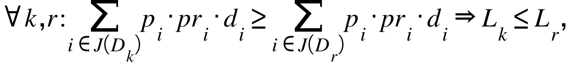 (5)

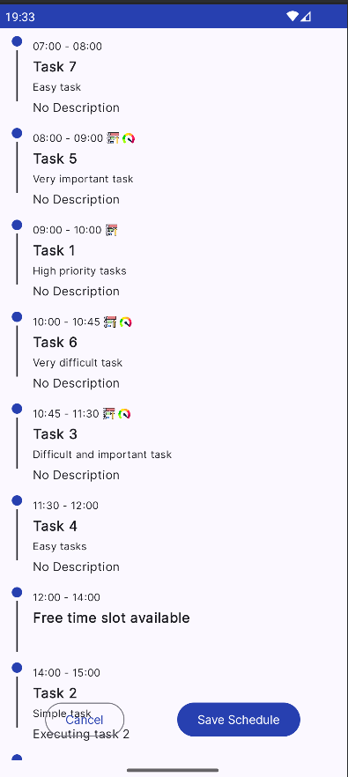
- New schedule built with the algorithm

where L_{k} – date at index k, which is the element of set L ordered in ascending order and L_{r} – date at index r, which is also the element of set L ordered in ascending order.
To identify an interval in the schedule for a new task, the number of idle periods within activity period must be minimized:
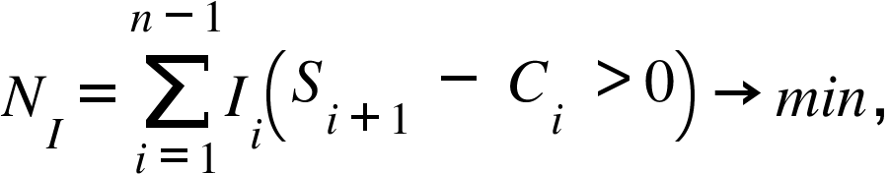 (6)
where I_{i} – function, which value equals to:
0, if S_{i+1} – C_{i} ≤ 0;
1, if S_{i+1} – C_{i} > 0,
N_{I} – number of idle periods.
To place the new task J_{N} among the tasks within the activity period [T_{min}, T_{max}], considering the fixed status f_{i} of each task and minimizing the number of idle periods within activity period.
The scheduling function on the client side can be used when adding a new task or changing the date and execution time of an existing task. The problem can be classified as single machine scheduling problem [5]. Each task executed on the machine has its duration in minutes, difficulty, which can be normal or high, and priority, which can be low or high. Schedule is being built with heuristic algorithm. It has two stages: selecting the date and selecting the time interval for task execution.
At the first stage, the algorithm determines the date for task execution based on the parameters of the new task and the workload of each date within the range specified by user before the algorithm starts. The workload is calculated based on durations, difficulties and priorities of tasks for each date in the specified range (5). Depending on the parameters of the new task, the algorithm recommends either the date with the lowest calculated workload or the nearest date within the specified range. The latter option is only considered if the new task has high priority and normal difficulty.
At the second stage, the algorithm determines a time slot for task execution within the activity period specified by user for the date, which was selected at the first stage. During the schedule building process, the algorithm tries to comply with constraints (1), (2), (3), (4).
The algorithm assigns to each task the earliest possible time slot. The schedule building process consists of four steps:
- Distribution of the tasks with fixed execution intervals within the activity period;
- Distribution of the high-priority tasks with unfixed execution intervals within the activity period;
- Distribution of the low-priority tasks with unfixed execution intervals within the activity period;
- Rearrangement of the tasks within the new schedule to minimize number of idle periods (6).
An acceptable schedule within the activity period on the selected date is the result of the algorithm, which was built in relatively short computational time.
Fig. 2 presents an example of the schedule, which was built with the algorithm. All tasks in the new schedule were distributed according to constraints that were specified before the start of algorithm.

Conclusion
The task scheduling system gives tools to describe upcoming tasks, build new schedule based on descriptions and save all the data. Additionally, the system can assist with determining the execution time of a new task by applying heuristic algorithm to build a new schedule. All user data can be stored either locally on the client side or on the remote server to provide continuous access.
The system helps users to increase their productivity while at the same time reduce the workload. Furthermore, system tries to balance the time spent on work or study and free time monitoring the progress of the tasks.
The system can be used across various situations and use cases. It can be used for planning household chores, creating a task execution plan for students and employees or combining the tasks from different categories such as work, studying and leisure. The most effective way to use the system is for getting recommended time to schedule tasks with deadlines but without fixed execution time.

References
1. S. Mbugua, V. Mony, prof. G. M. Nyabuto. Architectural review of Client-Server Models. International Journal of Scientific Research & Engineering Trends. – 2024. – vol. 10, is. 1. – P. 139-140.
2. Prof. K. M. Jadhav, prof. T. S. Patil, prof. P. S. Sutar, prof. H. S. Bhore. Review Paper on Database Basics for Developers : Understanding CRUD Operations. International Journal of Research Publications and Reviews. – 2025. – vol. 6, is. 2. – P. 2696-2697.
3.https://developer.mozilla.org/enUS/docs/Web/HTTP/Gu-ides/Session (referenced 23.04.2025).
4. https://jwt.io/introduction (referenced 23.04.2025).
5. Hongyun Xu, Quan Ouyang. The Review of the Single Machine Scheduling Problem and its Solving Methods. Applied Mechanics and Materials. – 2013. – vols. 411–414 – P. 2081-2084.

