System for Short-Term Job Search
Rekechynska Liubov, Zhurakovska Oksana
Department of Information Systems and Technologies
Igor Sikorsky Kyiv Polytechnic Institute
Kyiv, Ukraine
bubochka102003@gmail.com

Abstract. The paper considers a system for short-term job search, which aims to improve the interaction between employees seeking temporary employment and employers. It is proposed to use the ranking of vacancies to personalize the search using a weighted convolution of criteria. An interactive map has been added to visualize job offers, which allows users to plan their time more efficiently and keep track of vacancies even within their own neighborhood.

Keywords: short-term job, job search, ranking, interactive map, Multiple Attribute Decision Making Methods.

Introduction
The demand for short-term employment is steadily increasing in today’s socio-economic conditions [1], both among workers and employers. There are several reasons for this trend. Primarily, individuals seek to maintain control over their work schedules. They prefer flexible hours that enable them to balance employment with other activities. This category includes students who need to combine work with studies, individuals who have lost their primary source of income and are seeking new opportunities, and those who require an additional income stream, among others.
On the other hand, employers are often in need of quickly filling positions for temporary tasks. Services such as repair assistance, event coordination, or seasonal agricultural work are among the most common areas of short-term employment [2].
Most existing job search platforms primarily focus on long-term employment. This creates a gap for users interested in quickly and conveniently finding short-term jobs that meet their personal preferences, and for employers who need to hire workers for temporary tasks within a short time frame.
This paper presents the concept of the system for short-term job search, integrated with geolocation functionality, which allows job seekers and employers to interact efficiently. A key feature of the system is a vacancy map that visualizes available jobs based on geographic proximity, which is a crucial aspect of job accessibility [3]. Additionally, job listings are ranked according to specific criteria to personalize and accelerate the job search process.

Review of Existing Solutions
There are several platforms that allow users to browse job listings and submit their resumes so that employers can review candidates. Among the most popular platforms in Ukraine are Rabota.ua and Work.ua [4]. These platforms have a similar structure and functionality. They allow users to filter job postings or candidates based on various criteria such as employment type, education level, experience, expected salary, and more. While convenient for many users, these platforms do not specialize in short-term employment. Even when search queries such as “part-time job” or “short-term work” are entered, the search results primarily return long-term job offers.
In Ukraine, there are also platforms focused on service-based task execution. Based on a search and analysis of available services, the platform Kabanchik.ua appears to best align with the needs of short-term employment. This platform enables employers to post various types of temporary job categories, and workers can respond to those offers. Each job posting includes essential information to help candidates determine whether the job is suitable for them.
However, Kabanchik.ua also has certain limitations. One significant drawback is the lack of convenient categorization and ranking mechanisms. For job seekers, it is important to be able to filter vacancies based on personal preferences and relevant search criteria. Additionally, in the context of short-term employment, it is crucial to have the option to choose not only the city but also the specific district or neighborhood where the work is located. This functionality is essential for effective time management when completing short-term tasks.
Based on the analysis of current solutions and identified limitations, the goal of the system for short-term job search is to improve the process of finding short-term employment by providing ranking based on multiple criteria and incorporating a vacancy map that displays job locations. This allows users to find jobs within their local area or even within walking distance, depending on their preferences.

System Structure
The system for short-term job search is implemented as a web-based platform. This provides convenient access from various user devices, whether a laptop, smartphone, or any other gadget ensuring that users can connect to the platform regardless of their hardware. Furthermore, this format enables interaction between the two main user categories: workers and employers.
The system architecture follows a client-server model. JavaScript was selected as the primary development language due to its universality in creating both client-side and server-side components. The backend logic is handled by the Node.js platform. For data storage, MongoDB is used as the database management system. As a non-relational database, MongoDB offers flexible and convenient storage for data of various formats and structures.
Fig. 1 presents the general architecture scheme of the system.
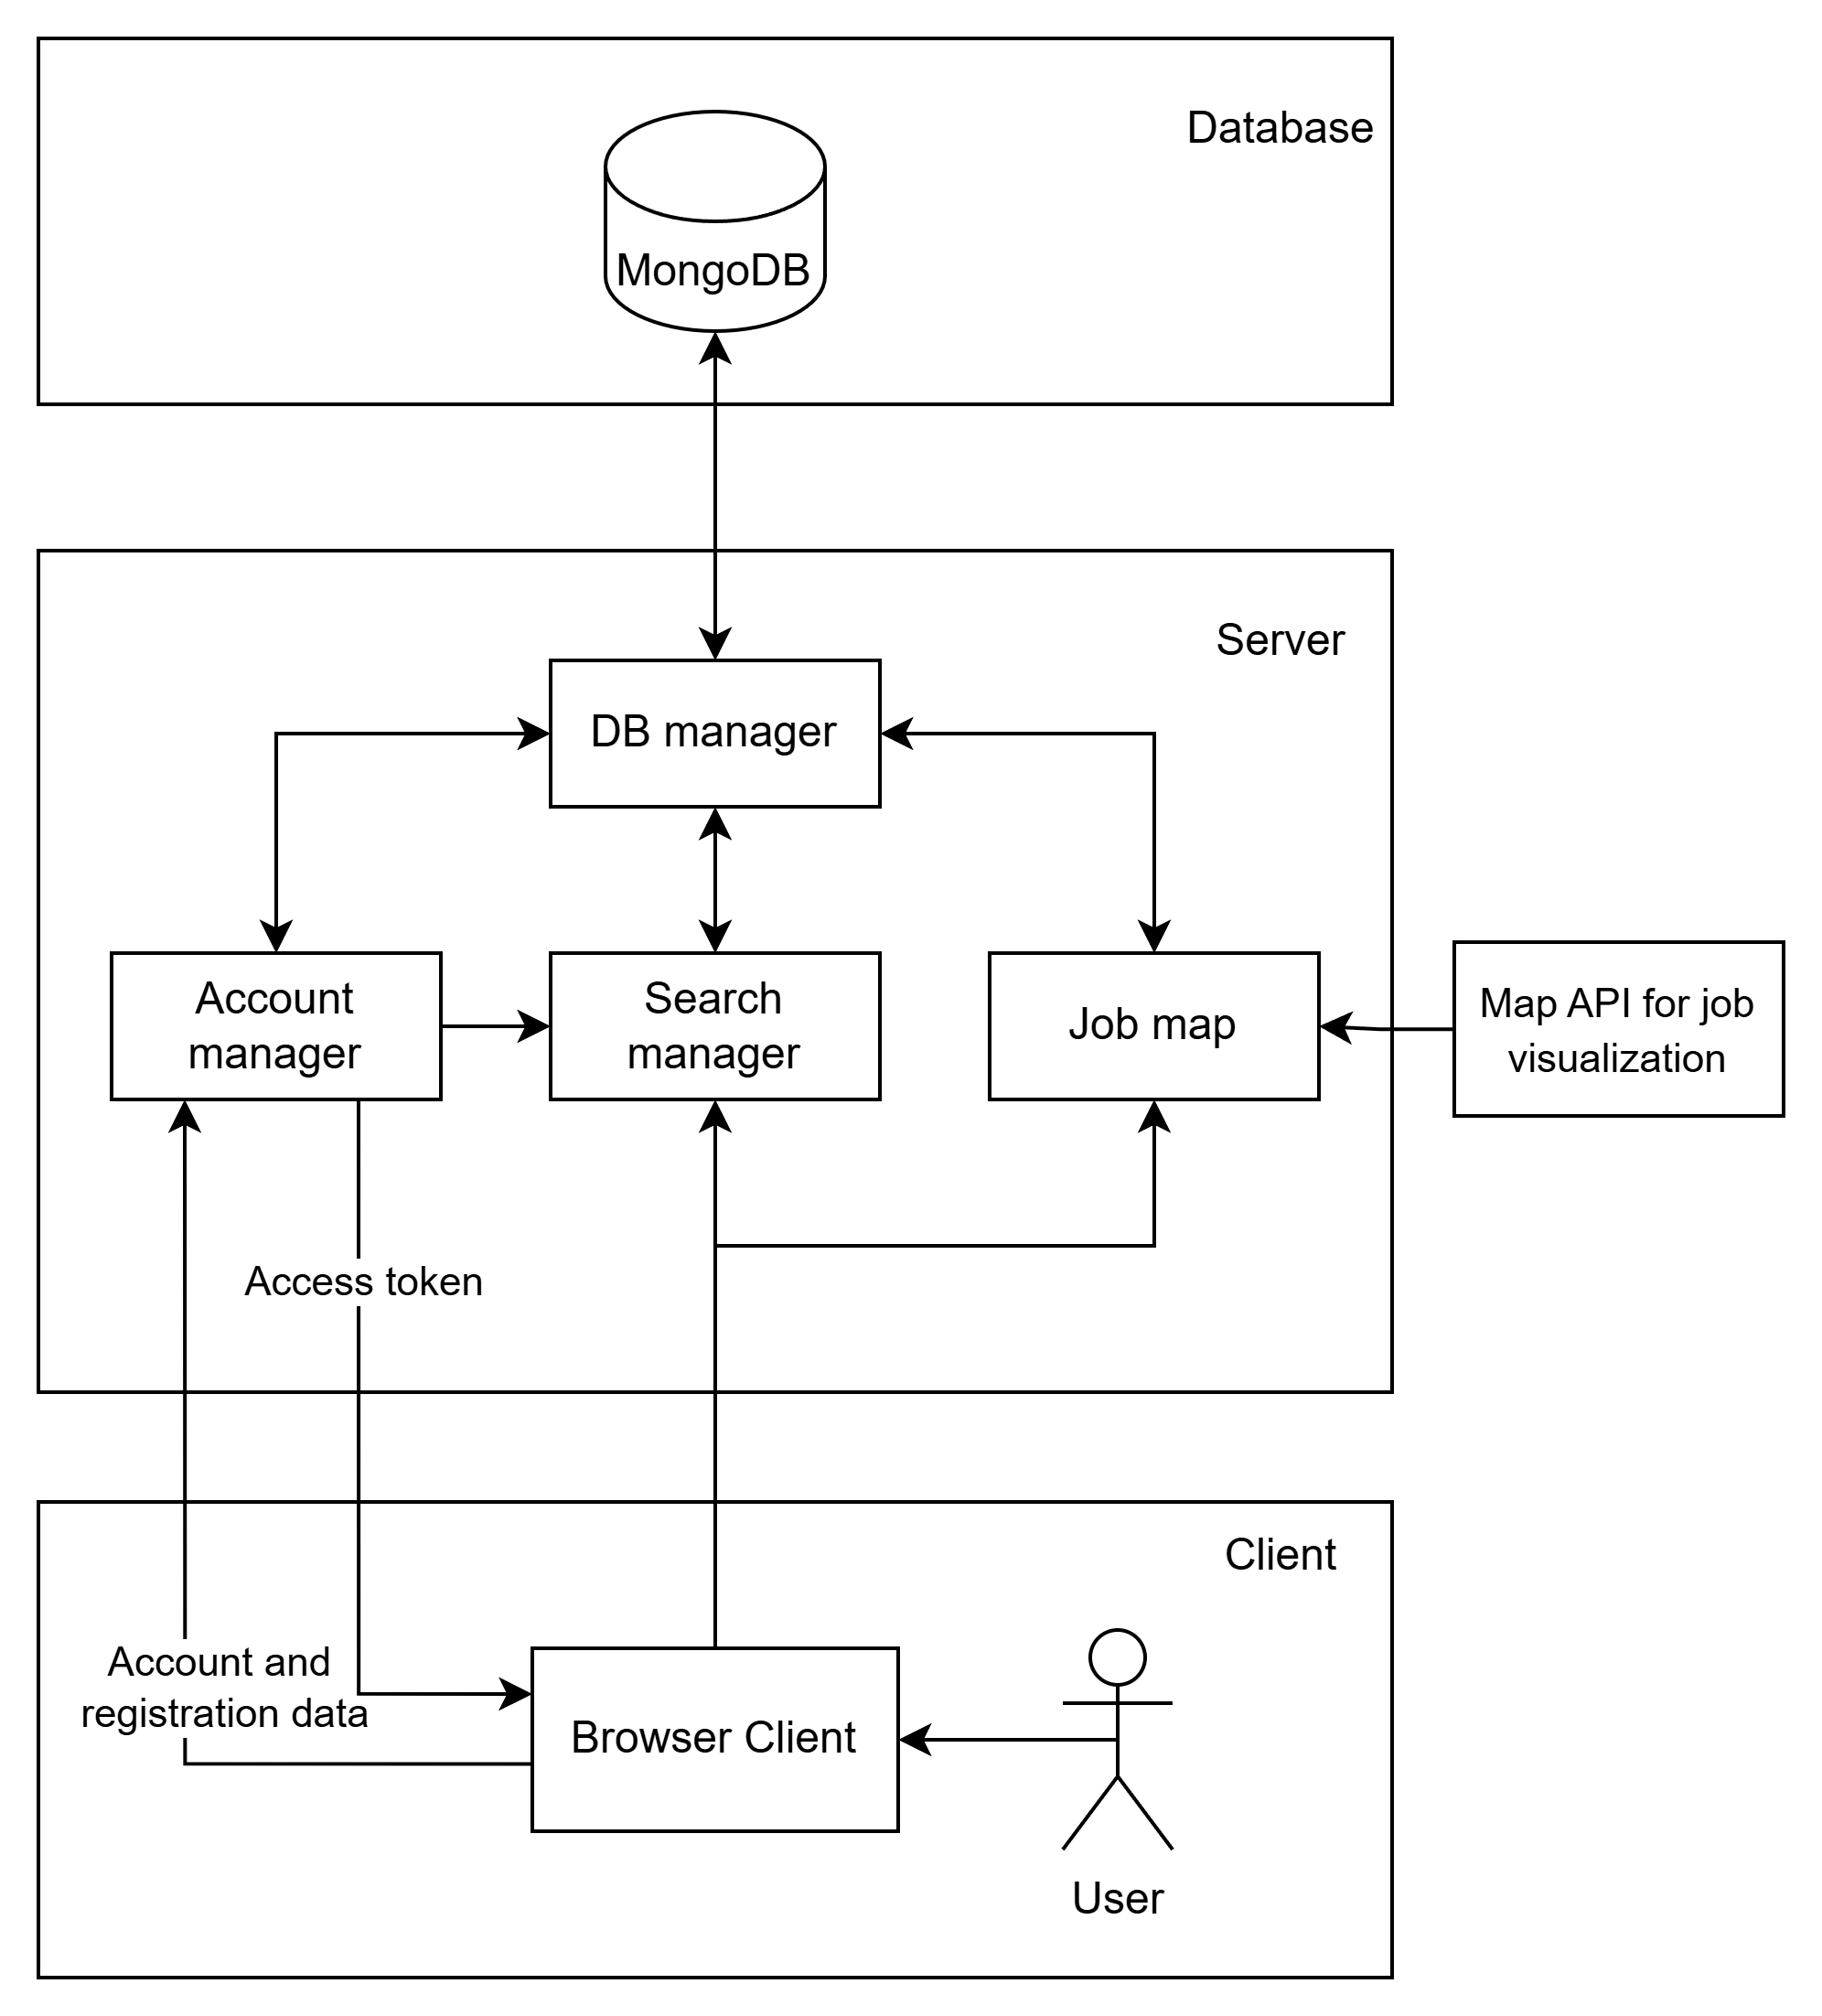

Fig. 1. The general architecture scheme of the system
The first element users interact with is the registration and login page. If a person wishes to respond to a job posting or create one, they must be registered in the system. Registration requires a phone number and an email address to ensure verification and account security.
A key component of the system is the user profile. This is a personalized space for any registered individual. Here, users can edit their personal information, such as phone number or geolocation. They can upload their resume to allow employers to assess how well a candidate matches the job requirements. Additionally, users may add further information about themselves or their company to better describe their experience, skills, or currently available vacancies.
One of the core features of the user profile is the ability to select ranking criteria for job listings. This functionality aims to provide the most relevant job opportunities tailored to each user, improving both the efficiency and personalization of the search process.
Several multi-criteria decision-making methods may be applied to the job ranking process, including VIKOR, TOPSIS, and the weighted sum model [5, 6]. Each method has its own advantages.
After analyzing these methods, the weighted sum model was chosen for vacant ranking due to its ease of integration into systems with a large number of listings.
The Weighted Sum Method is based on calculating a weighted sum of scores across specific criteria that help assess the attractiveness of each job offer. This approach implies that higher scores correspond to more favorable options, making it suitable for multi-criteria decision-making. Below are examples of key evaluation criteria:
- wage, assessed as the total compensation offered for completing a task. The higher the wage, the more attractive the job offer becomes;
- location convenience, which reflects the proximity of the job. It is calculated as an inverse value of the distance that needs to be covered to reach the job site;
- experience match, which is evaluated based on the number of relevant skills that align with the task requirements;
- employer reputation, determined by the average rating received after task completion. A higher score indicates greater reliability and integrity of the employer.
The overall score is calculated using the formula:

where – the weight of the i-th criterion, and – the score for that criterion.
This approach makes it possible to generate a personalized list of vacancies that are best suited to the individual.
The system supports two approaches for determining the weight values of criteria:
- automatic weight assignment, based on the information provided in the user’s profile. For example, if the user indicates a preference for jobs near their location, the system prioritizes distance when ranking vacancies;
- personalized weight customization, allowing the user to manually assign priority levels to each criterion through an intuitive and user-friendly interface.
Based on the weighted sum model, a search module was developed. While using it, the user can view a personalized selection of job listings. Filters are also available to accelerate the search process.
While browsing, workers can view employer ratings and, if needed, read reviews from previous employees. The rating system is updated after each task is completed. Both parties, employer and worker have the option to leave comments and assign ratings. These ratings influence future ranking and build trust in user profiles.
To simplify and visualize job listings, an interactive map is integrated into the system, displaying all currently active job offers.
When creating a job post, the employer specifies the task location, and the system automatically places a marker on the map. This feature enables users to monitor local opportunities within their district and optimize their time by minimizing travel between tasks.
Once a user selects a job they want to apply for, the employer receives a list of interested applicants. The employer can review their ratings and feedback. After selecting a candidate, a task confirmation form is generated, capturing key parameters such as deadlines, address, and other essential details.

For illustrative purposes, a diagram representing the system components has been developed and is shown in Fig. 2.
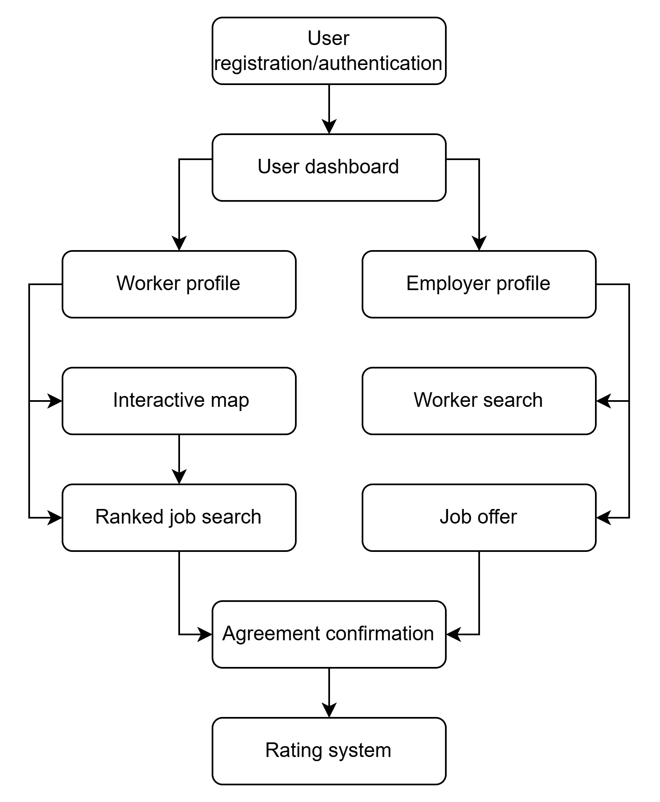

Fig. 2. Diagram of relationships between components
Thus, the structure of the System for Short-Term Job Search is designed to maximize user convenience and provides an intuitive step-by-step experience for both workers and employers.

Conclusions
The developed system for short-term job search facilitates the process of finding temporary employment for workers. At the same time, it enables employers to quickly identify qualified candidates to carry out specific tasks. A high number of potential users is expected, as the platform significantly simplifies the job search process, allowing individuals to find side jobs with minimal effort and time investment.
The architecture and core components of the system have been reviewed, along with a description of their interactions. The use of the Weighted Sum Model for job ranking increases the relevance of search results. Personalized search functionality helps users reduce the time spent finding suitable vacancies, which is crucial in the short-term employment sector. Additionally, the integration of an interactive map allows users to visualize available job opportunities, especially beneficial for those looking for work within their neighborhood or walking distance.
The system has promising potential not only at the city or national level but also for broader application. In the future, functional expansion is possible. One of the key enhancements could include the integration of AI-based modules that recommend job listings based on a user's interaction history and behavior within the system.

References
- Lorraine Charles, Shuting Xia, Adam P. Coutts. Digitalization and Employment. A Review. ILO. 2022. URL: https://www.ilo.org/employment/Whatwedo/Publications/WCMS_854353/lang--en/index.htm
- Non-standard employment around the world. International Labour Office - Geneva: ILO, 2016. URL: https://www.ilo.org/sites/default/files/wcmsp5/groups/public/@dgreports/@dcomm/@publ/documents/publication/wcms_534496.pdf
- The Impact Of Geolocation On Job Search Algorithms. URL: https://medium.com/@alliancejobsin/the-impact-of-geolocation-on-job-search-algorithms-7b36ae7c7818 (Accessed on: 26.04.2025)
- Unian.ua. economics. URL: https://www.unian.ua/economics/other/reyting-saytiv-z-robotoyu-v-ukrajini-12253731.html (Accessed on: 28.04.2025).
- Alinezhad, A., Khalili, J. New Methods and Applications in Multiple At-tribute Decision Making (MADM).-Springer, 2019.-233p.
- Papathanasiou, J., Ploskas, N. Multiple Criteria Decision Aid. Methods, Ex-amples and Python Implementations.-Springer, 2018.-173p.

