***Combined centralized-cooperative mathematical game model of UAV and UGV control***

Maksym Alpert

National Technical University of Ukraine “Igor Sikorsky Kyiv Polytechnic Institute”

Kyiv, Ukraine

max292009@gmail.com

Viktoriia Onyshchenko

National Technical University of Ukraine “Igor Sikorsky Kyiv Polytechnic Institute”

Kyiv, Ukraine

v.onyshchenko@kpi.ua

*Abstract.* This paper discusses the application of cooperative game-theoretic methods combined with centralized control strategies for optimizing unmanned vehicles operations. It addresses mission planning, resource allocation, and route optimization for unmanned vehicles coordination.

Keywords: unmanned vehicles, UAV, UGV, cooperative game theory, optimization, route planning, centralized control.

# Introduction

The exponential growth and complexity of UV (Unmanned Vehicles) operations, especially in tasks involving coordination between multiple units, have intensified the need for advanced optimization methods. Traditional methods of autonomous or semi-autonomous control become increasingly inadequate as mission complexity and uncertainty increase. Among various modern methodologies, game-theoretic methods have emerged as robust solutions for addressing these challenges, particularly the cooperative game theory combined with centralized control, ensuring optimal mission outcomes [1]. This paper details the development, analysis, and practical implications of integrating these methods into UV coordination tasks, specifically emphasizing search-and-rescue missions.

The UV systems have been extensively utilized in diverse operations, including civilian and commercial applications. The capability to perform sophisticated tasks autonomously, like territory monitoring, object tracking, and logistical support, places UV technology at the forefront of current and future technological advancements. However, managing these autonomous systems under constrained resources and uncertain environments requires innovative, flexible, and highly effective control strategies. This research proposes a combined centralized-cooperative mathematical game model to enhance UV management, particularly in critical missions.

# Methodology

The core of the proposed method revolves around cooperative game theory. Cooperative game theory is advantageous due to its ability to consider multiple agents (UVs) collaborating towards a shared objective. This method effectively manages interactions among multiple UVs by addressing several critical operational factors, including:

* Coverage area and its optimization.
* UV movement speed and trajectory efficiency.
* Payload management under severe limitations, including human, financial, and energy resource constraints.
* Optimal route planning among high uncertainty and risks, notably large static obstacle detection using neural network approaches [2].
* Strategic selection and optimization of UV charging stations to minimize downtime and operational disruptions [3].

# Mathematical Model Development

The developed mathematical model integrates cooperative game theory principles with centralized control mechanisms. Under this model, all UV operations are orchestrated through a singular control entity, streamlining command structure and resource management. The general payoff function, denoted *Ftotal*, encapsulates the comprehensive mission objective, defined by maximizing operational coverage while simultaneously minimizing resource utilization:

$F_{total}=\sum_{j=1}^{3}{{a_{j}F}_{j}-\sum_{j=4}^{5}{{a_{j}F}_{j}}}→max$



In this formula, *Fj* individually represents coverage, speed, payload, energy, and financial expenditure. Each parameter has an associated priority *aj*, ensuring total prioritization unity:

$\sum_{j=1}^{5}{a_{j}=1;}0≤a_{j}≤1\text{;}j=\overline{1,5}$ 2

It is assumed that all functions *fi* are normalized. *xi(t)* is the state of the *i*-th control object at time *t.* UV prioritization is described as follows (3):

$\sum_{i=1}^{N}{p_{i}=1;}0≤p_{i}≤1; i=\overline{1,N}$ 3

The specialized payoff functions for each operational component are structured comprehensively to ensure detailed optimization across the mission's various aspects.

Coverage optimization focuses on maximizing the area covered by UVs throughout the mission, taking into account the current state of each UV at any given moment to effectively address real-time demands (4).

$F_{1}=\sum_{i=1}^{N}{p_{i}*f_{i coverage}\left(x_{i}\left(t\right)\right)}$ 4

Velocity maximization aims to achieve the highest possible speed collectively for the UVs, enabling quicker response and shorter mission duration (5).

$F_{2}=\sum_{i=1}^{N}{p_{i}*f_{i velocity}\left(x_{i}\left(t\right)\right)}$ 5

Payload maximization addresses the efficient management and optimization of carried payload, crucial for accomplishing mission objectives, especially in scenarios like search-and-rescue operations where the timely and secure delivery of essential items can be mission-critical (6).

$F_{3}=\sum_{i=1}^{N}{p_{i}*f_{i payload}\left(x_{i}\left(t\right)\right)}$ 6

Moreover, the model includes energy consumption minimization, specifically formulated through a quadratic relationship with the control inputs of the UVs, where the energy function is represented as a square of the control input for each UV. This formulation effectively captures the nonlinear increase in energy consumption with aggressive maneuvering or rapid movements, thereby encouraging efficient operational patterns (7-8). *ui(t)* is the control function for the *i*-th control object (UV) at time *t*.

$F_{4}=\sum_{i=1}^{N}{p_{i}*f_{i energy}\left(u_{i}\left(t\right)\right)}$ 7

${f_{i energy}(u}_{i}\left(t\right))={\left(\left\|u_{i}\left(t\right)\right\|\right)}^{2}$ 

8

Similarly, financial cost minimization is modeled through an analogous quadratic relationship, reflecting the escalating financial expenses associated with heightened operational intensity or frequent adjustments during UV missions (9-10).

$F_{5}=\sum_{i=1}^{N}{p_{i}*f_{i finance}\left(u_{i}\left(t\right)\right)}$ 9

${f_{i finance}(u}_{i}\left(t\right))={\left(u_{i}\left(t\right)\right)}^{2}$ 

10

Additionally, an ideal payoff function, denoted as *Fideal* is introduced to benchmark the efficiency of actual mission outcomes against an optimal theoretical scenario characterized by zero energy and financial expenditures (11). This ideal scenario provides a clear performance target, enabling quantitative assessment and facilitating continuous improvements in operational strategies by evaluating the achieved efficiency relative to the maximum attainable effectiveness under ideal conditions (12).

$F_{ideal}=\sum_{j=1}^{3}{{a_{j}F}_{j}}$ 11

$Effectiveness=\frac{F_{total}}{F_{ideal}}*100\%$ 

12

# Results

Extensive simulation trials were conducted to validate the proposed model's effectiveness in realistic scenarios, such as coordinated search-and-rescue operations involving multiple UV types (UAV and UGV). The simulation results yielded compelling evidence supporting centralized-cooperative methodologies (fig.1):

* Efficiency of the Centralized-Cooperative model achieved 71.12%.
* Decentralized-Cooperative models with two and five control centers attained efficiencies of 65.06% and 22.66%, respectively.

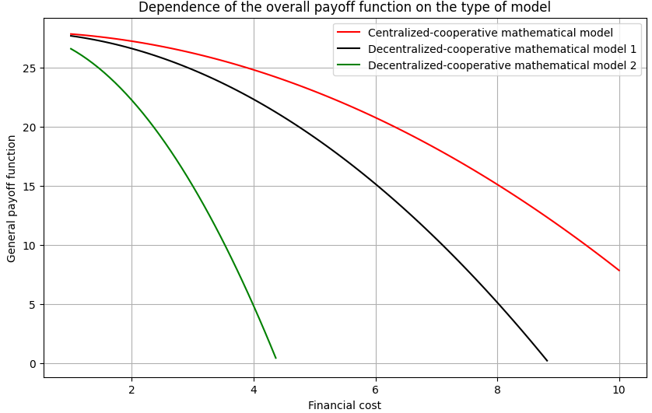

Fig. 1 Dependence of the payoff function on the type of model

# Practical implementation

Implementing the centralized-cooperative game-theoretic model involves strategic adjustments to UV control systems, emphasizing the following components:

* Efficiency of the Centralized-Cooperative model achieved 71.12%.
* Operator-centric control ensuring cohesive management of all UV operations through a single interface.
* Real-time monitoring and adaptive mission adjustments via advanced neural-network-driven obstacle detection.
* Optimized resource allocation across all UV units to ensure minimal downtime and maximum mission efficacy.

Advantages observed from practical implementation include reduced operational overhead, enhanced response times in critical mission scenarios, and optimized allocation of human, energy, and financial resources.

# Conclusion

The research demonstrates that integrating cooperative game theory and centralized control significantly advances UAV operational management. By streamlining command structures, enhancing coordination efficiency, and optimizing resource usage, the proposed methodology provides tangible operational and economic benefits. The findings underscore the viability and strategic importance of this integrated approach in managing complex UV missions effectively, paving the way for broader adoption in both civilian and defense sectors.

##### References

1. M. L. Cummings, “Operator Interaction with Centralized Versus Decentralized UAV Architectures,” in Handbook of Unmanned Aerial Vehicles, K. P. Valavanis and G. J. Vachtsevanos, Eds. Dordrecht: Springer, 2015, pp. 977–991. https://doi.org/10.1007/978-90-481-9707-1_117.
2. M. Alpert and V. Onyshchenko, “Recognition of Potholes with Neural Network Using Unmanned Ground Vehicles,” in Advances in Computer Science for Engineering and Education, vol. 134, pp. 209–220, 2022. https://doi.org/10.1007/978-3-031-04812-8_18.
3. M. Alpert, “Using Game Theory to Improve Drone Operations,” in Control Systems and Computers, vol. 1, pp. 57–61, 2024. <https://doi.org/10.15407/csc.2024.01.05>