Prospects for the Use of Morphological Filters in Rapid Image Processing Tasks
Oleksandr Rolik, Natan Smolii
Department of Information Systems and Technologies
Igor Sikorsky Kyiv Polytechnic Institute
Kyiv, Ukraine
smolii.natan@lll.kpi.ua

Abstract. Morphological operation is a technique used in image processing to modify and enhance digital images. It involves the use of a structuring element (analogous to the kernel in spatial filtering) that is applied to each pixel in an image to alter its value based on the surrounding pixel values.
Keywords: morphological operations, image processing, feature detection.

Introduction
Morphological operations are commonly used in image processing on stages of noise reduction or photo editing for such tasks as blurring or sharpening of images. However, primary data procession is not everything what they can be used for. Recent AI development proved that without such operations it is impossible to handle data properly. Mainly, these operations are used in image processing models, where models are used to fit values of filter kernels to training data and so, learn how to detect bigger features on the image. However, these filters are also used by humans for multi-layer image processing and since they were used there even before AI period began there existed a task of assembling a chain of filters in order to extract valuable numerical data from image.

Literature review
In the article [1], the principles of convolutional neural networks (CNNs) are described in detail, along with an illustration of how morphological filters are integrated into their architecture. The study provides insights into the synergy between morphological operations and deep learning techniques for enhancing image analysis performance.
A reference book [2] demonstrates the usage of Sobel filters for gradient extraction in images through the OpenCV library. Additionally, it offers explanations on the application of custom morphological filters with user-defined convolution kernels in various image processing tasks, such as edge enhancement and object detection.
The source [3] presents the foundational principles and algorithms for constructing custom morphological filters. These filters are shown to be effective in tasks such as noise reduction, feature detection, and general enhancement of image quality, using both classical and adaptive approaches.
The study [4] provides a practical example of using morphological filters for the detection and classification of specific regions in images. It also offers guidance on employing dilation and erosion operations as efficient techniques for reducing noise in edge-dense areas, thus improving the clarity of object boundaries.
Article [5] highlights the prospects of using drones for water sampling and presents a mathematical calculations and formulas for drone positioning in the global coordinate system. It provides fundamental recommendations for controlling a drone equipped with additional equipment, taking into account dynamic loads and shifts in the center of mass.The article also contains data on disturbing influences on the system that can disable the aerial vehicle and require calculated and calibrated compensation, indicating the need for computational resources to process the mathematical model of a drone with a dynamic center of mass that is subject to significant environmental influences.

Processes description

Convolution
Numerous image processing techniques have been developed for object detection tasks within visual data. Among classical approaches, the Hough Transform remains a well-established method, relying on the mathematical parametrization of desired geometric shapes to detect them within an image. Despite its utility in controlled environments, the Hough Transform presents notable limitations when applied to scenes containing a large number of objects of unknown or irregular forms. Furthermore, the method often requires solving high-dimensional optimization problems, which hinders its applicability in real-time or computationally constrained scenarios. Additionally, this technique is inherently unsuitable for tasks requiring semantic or instance-level image segmentation, as it lacks the capacity to generalize beyond predefined geometric primitives.
In contrast, modern segmentation methods based on convolutional neural networks (CNNs) have demonstrated significant capabilities in pixel-level classification. These networks are capable of capturing both local contextual information and high-level structural features such as surface textures and visual similarities to known object classes within training datasets. However, segmentation architectures such as U-Net, DeepLab, or Mask R-CNN are computationally intensive and require large volumes of annotated data for supervised training. Moreover, their resource demands far exceed those of traditional object detectors, which generally operate on region-based localization strategies and serve as precursors to full segmentation pipelines.
When considering real-time video stream processing—one of the most critical tasks in modern computer vision—a number of practical challenges emerge. Among the most prominent are the trade-offs between detection speed, accuracy, and computational efficiency. Current state-of-the-art object detection pipelines often rely on neural network architectures from the YOLO (You Only Look Once) family, which are specifically optimized for high-speed inference. These models demonstrate favorable frame-per-second (FPS) performance, making them well-suited for real-time applications; however, they tend to offer lower detection accuracy and robustness compared to other, more complex detection or segmentation-oriented neural networks, such as RetinaNet, Faster R-CNN, or semantic segmentation models.
In the context of object tracking, a different class of algorithms is typically employed. Methods such as CSRT (Channel and Spatial Reliability Tracking), KCF (Kernelized Correlation Filters), and MOSSE (Minimum Output Sum of Squared Error) offer effective tracking capabilities while maintaining relatively low computational overhead. Their lightweight nature allows them to be deployed on resource-constrained platforms, such as embedded devices or edge processors, without significant degradation in performance. This makes them a practical choice for scenarios where neural tracking approaches (e.g., deep SORT or transformer-based trackers) may be infeasible due to latency or power limitations.
Morphological operations constitute a class of image processing techniques based on the application of a convolution-like operation using a predefined structuring element. These operations are designed to modify the spatial structure or "morphology" (in analogy to its use in linguistics as the study of form) of an image. Morphological transformations are typically employed to enhance specific object shapes, extract structural features, or suppress unwanted patterns such as noise or irrelevant textures.
Depending on the selected operation—such as dilation, erosion, opening, or closing—morphological processing can emphasize or remove particular spatial configurations within the image. For example, dilation tends to expand bright regions, whereas erosion contracts them. These operations are particularly effective in binary or thresholded grayscale images where object boundaries are clearly defined.
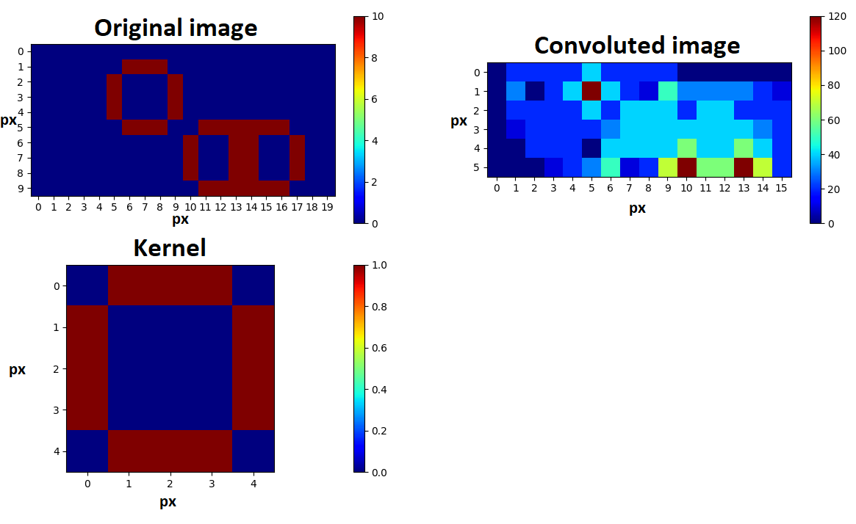
- Exampe of convolution operation
A practical illustration of morphological processing used to detect circular objects is shown in Fig. 1. In this example, morphological filtering with a circular structuring element facilitates the enhancement and localization of circular shapes within the input frame, demonstrating the utility of this technique in geometric pattern recognition tasks. The original input image is shown in the top-left panel. The structuring element used for morphological convolution is depicted in the bottom-left corner. The resulting convolved image is presented in the top-right panel. Color maps correspond to value intensities, and axes indicate image dimensions in pixels.
This work proposes the use of morphological transformations as a foundation for high-level image analysis, specifically for the detection of generalized, higher-order objects rather than traditional low-level features such as gradients or edges. By leveraging the structural specificity offered by morphological operators, it becomes possible to isolate abstract visual patterns relevant to task-oriented perception.
To validate the approach, a series of experiments were conducted within the Gazebo robotic simulation environment. The test scenario involved three autonomous aerial vehicles (UAVs) of the same physical model, each assigned a distinct operational role. Two of the drones were tasked with searching for and localizing a moving object within the simulated environment. The third UAV was responsible for maintaining its position directly above the localized object, effectively enabling coordinated tracking behavior.
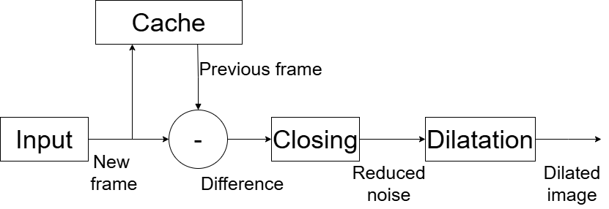
- Structure of used video processing pipeline

Object detection in the proposed system was performed using a morphological transformation pipeline, illustrated in Fig. 2. This pipeline enables the identification of changes between consecutive video frames through elementary frame differencing. By computing the pixel-wise difference between successive frames, the system highlights motion-induced regions which are further refined through morphological operations to suppress noise and enhance coherent structural features.
The overall architecture of the transformation chain is designed to be computationally lightweight while still providing sufficient sensitivity to dynamic changes in the scene, making it suitable for deployment in real-time video processing scenarios involving mobile platforms. Following the computation of inter-frame differences, a thresholding operation is applied to the resulting difference image to convert it into a binary format. This binarization step effectively filters out low-intensity variations caused by minor environmental movements or camera jitter—particularly relevant given the use of UAV-mounted cameras, which are prone to micro-movements during flight.
To further suppress noise and improve the coherence of detected regions, a morphological closing operation with a 5×5 convolution kernel is applied. This step helps eliminate small holes and bridge narrow gaps in the binary image, resulting in more stable and structured representations of moving objects.
Subsequently, a dilation operation using a larger 11×11 kernel is performed to aggregate fragmented detection points that likely belong to the same object. This enhances the spatial continuity of the detected regions and facilitates the morphological consolidation of object contours, enabling more reliable tracking and classification in later stages of the pipeline.
A comparison between the original image and the results of the morphological processing pipeline is shown in Fig. 3. After the morphological operations have been applied, the resulting set of points is reduced to a single representative point, which characterizes the center of the moving object's cluster. This point is then used to approximate the position of the moving object within the image frame.
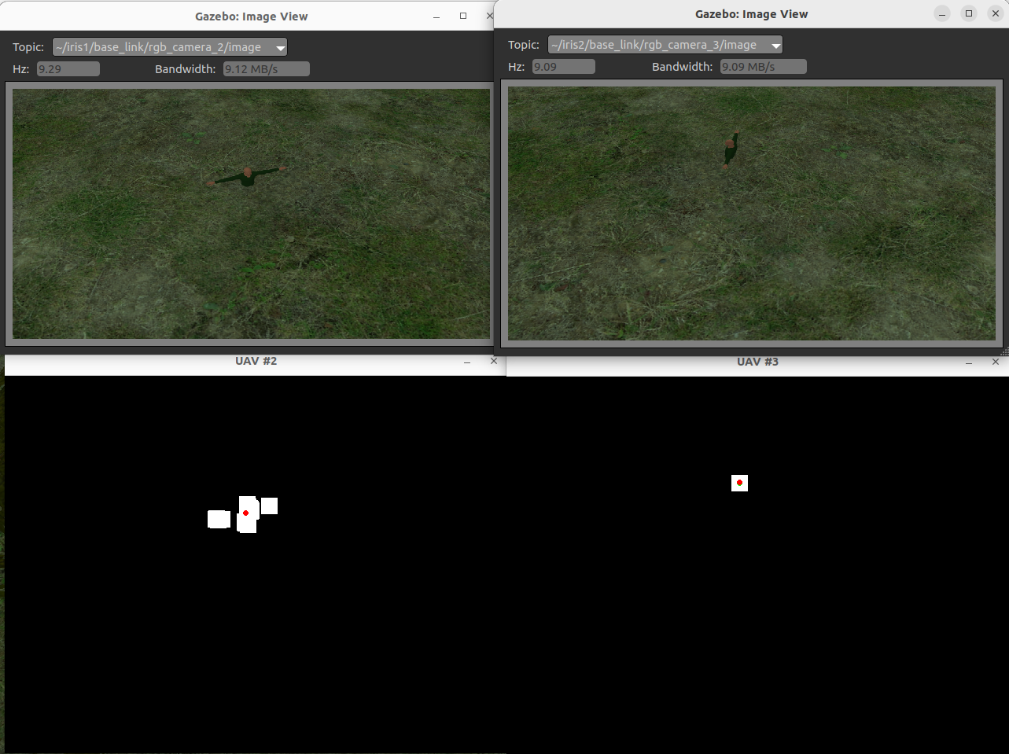
- Unprocessed and processed images.

While this method is not perfect and has inherent limitations—particularly in cases of occlusion or overlapping objects—it serves as a practical and computationally efficient approach for estimating the position of a moving object. Despite its simplicity, the method provides a reasonable estimation of object localization that is sufficiently robust for many real-time tracking applications, especially when computational resources are limited. Transformations for converting iamge points into 3D vectors require steps described below.
The calculation of the optical axis vector OA in the drone's coordinate system (CS) for a static hover, with tilt angles around the OX and OY axes equal to φ and θ, respectively, considering the vector OX [1.0, 0.0, 0.0] as the reference for the drone, is performed as follows:
, (1)
, (2)
. (3)
The projection of point P on the image to a spatial vector in the camera's coordinate system uses values such as the focal length f in millimeters along the x and y axes, as well as the target image dimensions I_{w} and I_{h}, and is performed using the following formula:
. (4)
That requires further transformation into the world coordinate system (CS) with following matrix should be used:
. (5)
For the subsequent transformation into a vector associated with the current orientation of the drone, which is typically represented in flight controllers as a quaternion, it is necessary to form the orientation quaternion for the obtained spatial vector and then rotate it to the drone's orientation quaternion. The following transformations are performed:
. (6)
Then, the resulting quaternion PQ is calculated based on the drone's orientation quaternion as follows:
. (7)
The resulting formula for transferring a point on the image to a spatial vector in the world coordinate system:
. (8)
Subsequently, after obtaining two direction vectors for the moving objects, it is necessary to solve the problem of finding the two closest points that belong to two lines and determining the intermediate point that nullifies the discrepancies in coordinate estimation. The points that belong to the lines can be found using the formula A=B+K⋅t, where t can be calculated by performing the operations described in the following formulas:
, (9)
, (10)
, (11)
Also, for further research, a comparison of image processing time depending on image resolution was carried out. For testing, a randomly generated black-and-white image of the specified size was used, on which the following operations were performed:
- three-stage convolution with filters of random sizes to measure the impact of convolution operations on processing time;
- exponential raising of pixel values and raising the result to the 5th power to determine the time cost of mathematical operations on data arrays;
- loop iterating through values in each row until a certain number is found, as an imitation of user-defined algorithmic image processing.
The results of the study are shown in Fig. 4:
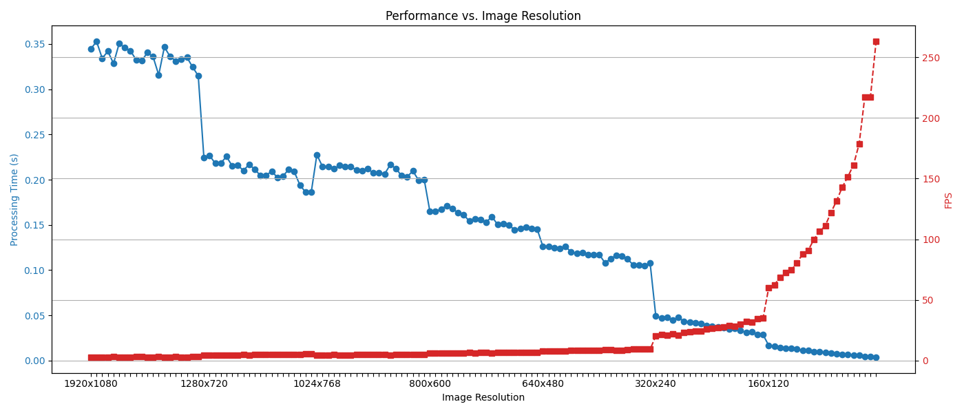
- Measured dependencies between processing time and image resolution.
The illustration presents two color graphs showing the time required to process an image of the specified resolution (blue graph with the scale on the left) and the expected frame rate (red graph with the scale on the right) at the output of the transformation pipeline. The frame rate graph can be used when designing systems with strict frame rate requirements, as this parameter is typically the most critical in system specifications.
It can be observed that for images processable by humans (resolutions from 1920x1080 to 640x480), the image processing time using the proposed test method decreases linearly, while an exponential drop is only observed for very small image sizes (320x240 and below), the processing of which results in significant accuracy loss. The accuracy loss is due to the fact that, with a fixed camera field of view, different image resolutions yield different levels of discretization for the captured image. As a result, when applying the transformation from formula (4), the obtained results vary significantly and affect the precision of the calculated final position using formula (11). Additionally, the graph shows a stable increase in processing time for a resolution of 1024x768, which should be considered during image processing.
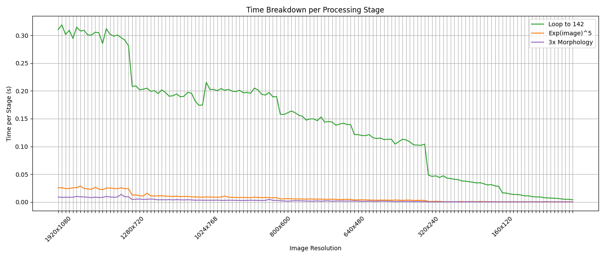
- Processing time splitted between three types of image processing tasks.

In Fig. 5, the time expenditures for each proposed processing stage are shown separately.
The green color indicates the time spent on the custom loop for processing pixel values, orange denotes the time taken for mathematical operations, and blue represents the time required to perform convolution operations; the blue graph shows the time expenses for mathematical operations on the image.
It can be seen that the greatest time costs are associated with the custom pixel iteration loop, indicating that the main method for optimizing image processing time is to eliminate components responsible for direct iteration from the processing program and shift to using specialized libraries for mathematical operations (NumPy, TensorFlow, SciPy, GLM), as they provide up to a tenfold reduction in processing time in some cases, which can be observed at a resolution of 1920x1080. Additionally, the analysis of this graph indicates that the increased processing time at a resolution of 1024x768 is specifically due to the use of the custom loop and cannot be avoided without a deep understanding of the programming language used to write the processing application.

Results
A thorough review of existing real-time video stream processing techniques for the detection and tracking of higher-order morphological structures has been conducted. Based on the insights from the analysis, a prototype image processing module was implemented using fundamental morphological operations. The system demonstrates the capability to extract and interpret structural patterns in video data by leveraging a mathematical framework tailored to morphological transformation outputs.
An analytical performance evaluation revealed the correlation between image resolution and processing latency. The results were presented in the form of resolution-dependent frame rate graphs, offering practical insights into system scalability. These findings led to a set of optimization recommendations.

Acknowledgment
The research was by the National Research Foundation of Ukraine under project No. 2023.04/0077 "Drone for water sampling".

References
- Yamashita, R., Nishio, M., Do, R.K.G. et al. Convolutional neural networks: an overview and application in radiology. Insights Imaging 9, 611–629 (2018). https://doi.org/10.1007/s13244-018-0639-9
- G. Bradski and A. Kaehler, Learning OpenCV: Computer Vision with the OpenCV Library. O’Reilly Media, 2008. [1, p. 148]
- P. Maragos and L. F. C. Pessoa, “Morphological filtering for image enhancement and detection,” in The Image and Video Processing Handbook, Academic Press, 2000, pp. 1–26.
- F. G. B. De Natale and G. Boato, "Detecting Morphological Filtering of Binary Images," in IEEE Transactions on Information Forensics and Security, vol. 12, no. 5, pp. 1207-1217, May 2017, doi: 10.1109/TIFS.2017.2656472.
- Polishchuk, M., & Rolik, O. (2024). Improvement of Technological Equipment Drone for Water Sampling: Design and Modeling. FME Transactions, 52(2), 237–245. doi: 10.5937/fme2402237P

