***Multi-UAV mission planning models***

Koval Vadym, Zhdanova Oleva, Popenko Volodymyr

Igor Sikorsky Kyiv Polytechnic Institute

Kyiv, Ukraine

*Abstract.* This paper focuses on the three variations of the UAV route planning problem, taking into account constraints on flight range and recognition radius. A novel approach is proposed that reduces more complex problem instances to parallel solutions of a basic problem without service points. This modular structure enhances computational efficiency and improves routing accuracy by enabling flexible distribution of targets among segments or individual UAVs.

Keywords: unmanned aerial vehicles (UAVs), multi-UAV mission, path optimization, target inspection, route smoothing.

# Introduction

The UAV is an autonomous drone that can fly missions independently of a human pilot [1]. In modern monitoring and reconnaissance tasks performed using unmanned aerial vehicles (UAVs), efficient planning of inspection routes plays a crucial role. Depending on the technical limitations of UAVs – such as flight range, recognition radius, and the availability of service points – it becomes necessary to formalize and solve various routing problem scenarios. Planning an acceptable trajectory, known as the UAV path planning problem [2], is necessary to enable any mission. An effective option for the use of UAVs is the solution of tasks by a group of UAVs acting as a team [3].

The paper considers three meaningful formulations of the UAV route planning problem with increasing complexity: from a single-UAV problem without intermediate service points (referred to as the basic problem) to a multi-UAV problem with multiple service points. The idea of constructing efficient routes for the basic problem is presented. The decomposition-based approach is proposed, which reduces more complex problems to a series of basic subproblems. This enables both improved computational efficiency and greater flexibility in constructing more accurate routes.

# Problem 1 (single UAV, no service points)

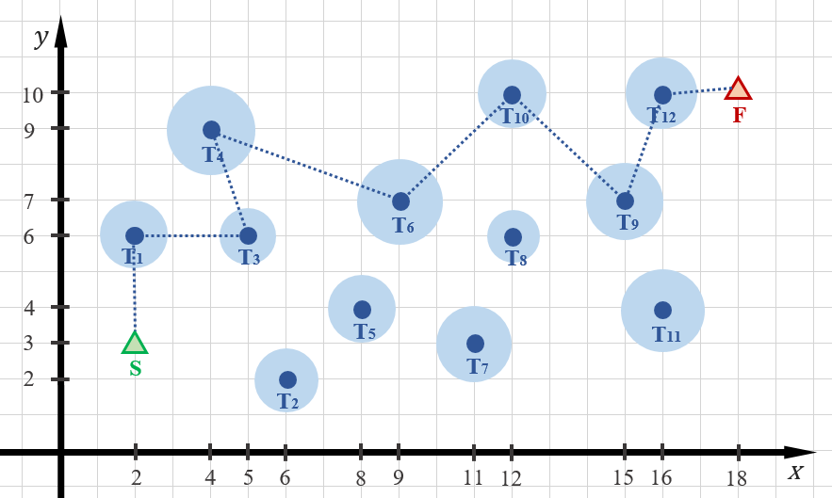

Fig. 2. UAV route passing through the centers of the targets

This problem represents the simplest case: it does not involve the use of intermediate service points.

Given:– number of targets;  – set of targets; – coordinates of the target ; one UAV;– maximum flight range (km) of the UAV without recharging;– maximum recognition range (km) of target  by the UAV camera;– UAV’s take-off point;– coordinates of the UAV’s take-off point;– UAV’s landing point;– coordinates of the UAV’s landing point. The UAV follows a route that begins at a starting point , covers a number of targets, and ends at a final destination . During the flight, the UAV inspects a target if it is within range – that is, at a distance not exceeding the maximum recognition radius for that target. The UAV’s flight endurance allows it to travel a limited distancewithout requiring energy replenishment. The objective is to determine a route that enables the UAV to inspect the maximum possible number of targets from the given set .

## Example of problem 1

Consider a scenario with . Figure 1 shows the layout of the targets and the corresponding recognitions.

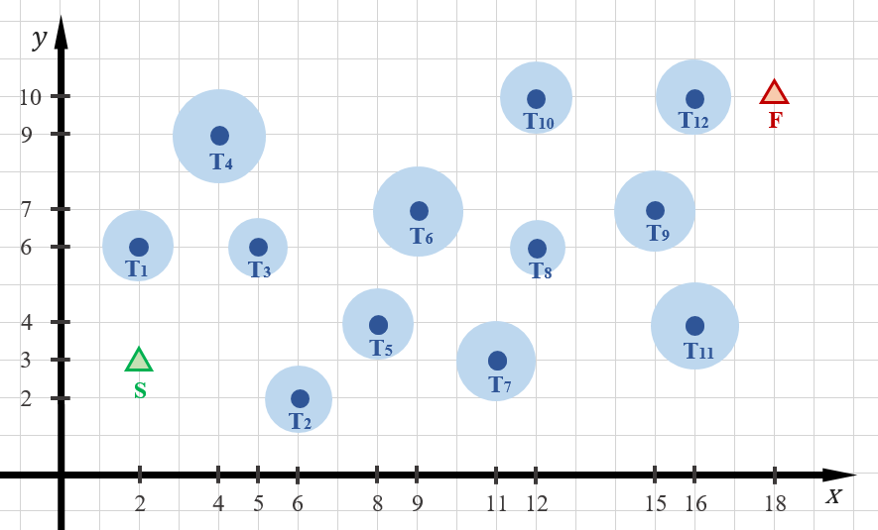

Fig. 1. The layout of the targets and the corresponding recognition zones

In the classical approach to UAV route planning, it is assumed that the vehicle flies directly through the center of each target to be inspected. While this trajectory ensures full coverage, it is often redundant in terms of overall route length.

In the classical route construction approach, each breakpoint corresponds to the center of one of the targets, meaning the UAV flies directly over the geometric center of the inspected target. Figure 2 illustrates the example of the classical route.

A smoothed route is a polyline or curve that does not pass through the target centers but instead approaches them within the allowable recognition radius. In other words, a target is considered recognized if the distance from any point along the route to the target does not exceed a given threshold.

This approach allows for:

– reducing the total route length by avoiding unnecessary detours;

– maintaining inspection efficiency without decreasing the number of covered targets;

– providing greater flexibility in route design, especially in cases with flight distance constraints between service points.

So, the length of the constructed routes can be significantly reduced by smoothing them – i.e., by forming trajectories in such a way that the UAV flies near the target, not necessarily through its center, but within the permissible recognition zone. Figure 3 includes an example of the smoothed route for the UAV; for clarity, the corresponding unsmoothed trajectories are also displayed.

Fig. 3. Classical and smoothed routes of UAV

When smoothing UAV flight routes, it is important to recognize that this method is not always optimal for constructing sub-routes. In certain cases – depending on the movement direction from the current point to the next two (i.e., the shape of the resulting polyline) – it may be more effective to use the classical sub-route format, where the UAV flies directly over the center of the target, rather than implementing a smoothed path that only touches the edge of the target area within the recognition range of the onboard camera.

# Problem 2 (Single UAV and service points)

This task is a generalized case of the previous one.

Given:– number of targets; – set of targets; – coordinates of the target ; one UAV;– maximum flight range (km) of the UAV without recharging;– maximum recognition range (km) of target  by the UAV camera;– UAV’s take-off point;– coordinates of the UAV’s take-off point;– UAV’s landing point;– coordinates of the UAV’s landing point.– number of service points for the UAV; – set of intermediate landing points.

The UAV follows a route that starts at the starting point , covers certain targets, and ends at the finishing point . During the flight, the UAV inspects the target , which is within range, i.e., at a distance not exceeding the maximum recognition radius . The maximum flight resource of the UAV allows it to cover a distance of up to  kilometers without recharging. Thus, the distance between any two consecutive route points (including the starting, intermediate, and finishing points) must not exceed. The UAV has  service points. These intermediate points  can be used for technical maintenance or resource replenishment and are part of the set of permissible landing points on the route. Each point may be visited more than once. The task is to determine the UAV routes that allow inspecting all targets from the set in the minimum time.

## Example of problem 2

Consider the task with parameters: . Figure 4 illustrates the inspection routes of certain targets by a single UAV using service points.

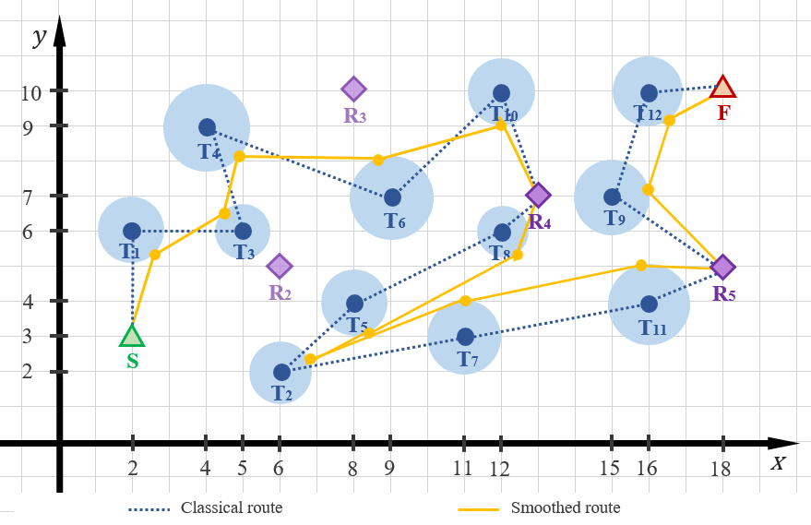

Fig. 4. Route variants: through target centers vs. smoothed path with service stops (with stops at intermediate service points)

# Problem 3 (multiple UAVs and service points)

Given:– number of targets; – set of targets; – coordinates of the target ;– number of UAVs; – set of UAVs;– maximum flight range (km) of the UAV without recharging the flight resource ;– maximum recognition range (km) of target  by the camera installed on the UAV  ;– take-off point of UAV ;– coordinates of the take-off point of the UAV ;– landing point of UAV ;– coordinates of the landing point of the UAV ;– number of service points for UAV ; – set of intermediate landing points for the UAV .

Each UAV  moves along a route that starts at the starting point , covers certain targets, and ends at the finishing point . During the flight, the UAV inspects a target that is within its range, meaning the target is within the maximum recognition radius set for the UAV-target pair. The maximum flight range of the UAV  allows it to travel a distance  without recharging that does not exceed a certain limit. Therefore, the distance between any two consecutive points on the route (including the starting, intermediate, and finishing points) must not exceed this limit .

Each UAV  is assigned  of service points. These intermediate points  can be used for maintenance or resource replenishment and are part of the set of permissible landing points along the route. Each point may be visited more than once. The task is to determine the UAV routes that allow inspecting all the targets in the set in the minimum time.

## Example of problem 3

To illustrate the above, consider a task with the parameters:.

It is assumed that , meaning that the cameras installed on both UAVs have the same recognition range characteristics. Figure 5 illustrates the inspection routes of certain targets by two UAVs using service points.

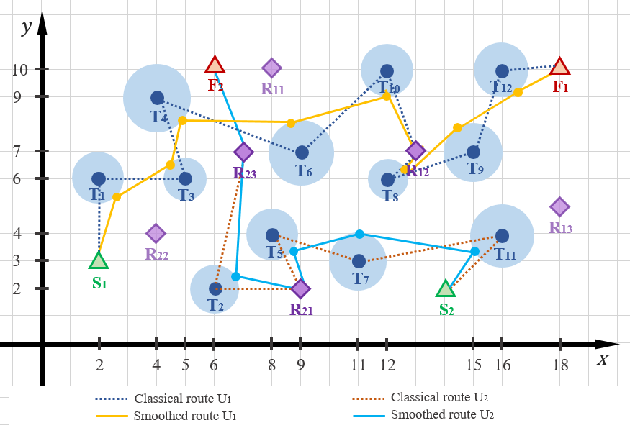

Fig. 5. Classical and smoothed routes for two-UAVs mission

# General algorithms description

Task 1 is a fundamental (basic block) for the algorithms solving problems 2 and 3. The idea of the algorithm for solving problem 2 is to treat each permissible subsequence of route points (including service points) as a separate implementation of task 1, and then combine the obtained partial solutions.  
The idea of the algorithm for solving problem 3 is based on solving the corresponding task 2 for each UAV. At the same time, the process of route construction can be performed in parallel, which not only increases computational efficiency but also allows flexible decisions regarding the distribution of targets among UAVs. This, in turn, promotes the formation of more accurate and balanced routes, as each target can be assigned to the UAV for which its inclusion is the most beneficial in terms of route length and coverage. In general, for this type of task such algorithms as ant colony optimization (MMACO) and artificial Bee Colony (ABC) are considered among the most appropriate [4].

# Mathematical model of Problem 1

## Variables (quantities to be determined)

 is the UAV route, where  – the coordination of the route breakpoints.

*Constraints*

1) Target coverage constraint: considering that a target can be surveyed not only at the waypoints but from any point along a route segment (i.e., between two waypoints), if the distance from the target to the segment does not exceed the recognition radius, the constraint is as follows: for each target to be considered surveyed, there must exist at least one segment of the route , such that the distance from to the segment does not exceed the recognition radius of the target :



where  is the shortest Euclidean distance from a point ​ to a line segment .

2) Route length constraint: the total length of the route must not exceed a given maximum distance :



where is the length of the segment .

3) Binary constraint for target survey: .

4) Waypoint coordinate constraint: the coordinates of the waypoints  can be arbitrary, selected from a set of permissible points, or determined in a specific manner.

*Auxiliary problem*

Calculating the distance from a point  to a segment , where ,  involves two steps. First, a projection parameter is calculated:

.

Then the shortest distance from the point to the segment is determined using that parameter:



##### Conclusions

Three problem formulations are proposed. The complex problems (1 and 2) are reduced to a series of independent sub-tasks of type 3. In the case of problem 2, the route is presented as a sequence of segments between permissible points (start, service points, finish), each of which is solved as a separate task 3. Problem 1 is reduced to the parallel solution of problem 2 for each UAV. This approach ensures modularity and allows for an efficient distribution of targets among UAVs, taking into account coverage and route length. The work formulates a mathematical model for task 3, which considers the ability to recognize a target not only at the route points but also along its segments. The proposed hierarchical task reduction scheme allows for solving UAV route planning problems, taking into account practical constraints. Task 3 serves as a universal component that enables the effective construction of more complex routes and the scalability of the approach to a larger number of devices.

##### References

1. A. Barnawi, K. Kumar, N. Kumar, N. Thakur, B. Alzahrani, and A. Almansour, “Unmanned aerial vehicle (UAV) path planning for area segmentation in intelligent landmine detection systems,” Sensors, vol. 23, no. 16, p. 7264, Aug. 2023.​
2. S. Ghambari, M. Golabi, L. Jourdan, J. Lepagnot, and L. Idoumghar, “UAV path planning techniques: A survey,” RAIRO - Operations Research, vol. 58, no. 4, pp. 2951–2989, Mar. 2024.​
3. L. Hulianytskyi and O. Rybalchenko, “Optimization of decisions when planning a UAV group mission with alternative depots,” in Proc. III Int. Sci. Symp. “Intelligent Solutions” (IntSol-2023), Kyiv, Ukraine, Sep. 27–28, 2023, CEUR Workshop Proc., vol. 3538, pp. 245–256, 2023.
4. M. Rahman, N. I. Sarkar, and R. Lutui, “A survey on multi-UAV path planning: Classification, algorithms, open research problems, and future directions,” Drones, vol. 9, no. 4, p. 263, Mar. 2025.